

UX Portfolio

Bentley University

Table of Contents

INTRODUCTION 2

PROTOTYPING 2

EventHelppo App: 2

Justify-app: (in progress) 3

USABILITY TESTING 5

Access management system: (in progress) 5

HEURISTIC EVALUATION 6

New England Journal of Medicine (NEJM) website: 6

UX Research 7

Currentchoice.com: (in progress) 7

# INTRODUCTION

This portfolio provides an overview of my work in UX design and research. This document is divided into sections based on different skills.

# PROTOTYPING

My work involving paper prototypes, wireframes, and software prototypes in different projects have been mentioned in this section.

## EventHelppo App:

This is an academic project for an IT course (Database management) where we developed an event management app called ‘EventHelppo’. We used MySQL as the database management system for the app and developed a prototype of the front end application to present the functionality of the app.

No. of Team members: 6

My major contributions: MySQL coding and prototype development

Tools used: Smartdraw, MySQL, “Justinmind” prototype, Livecode

Project flow:



Application Prototype samples:

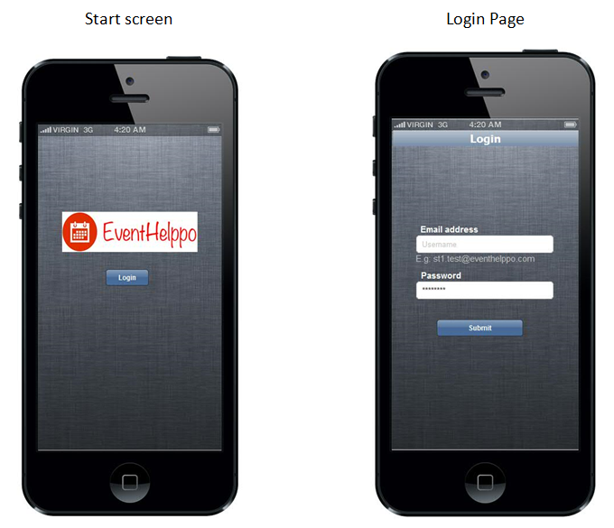 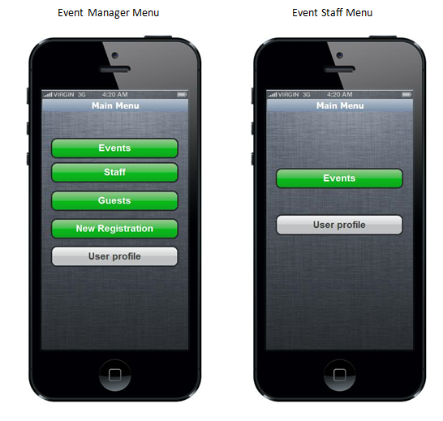

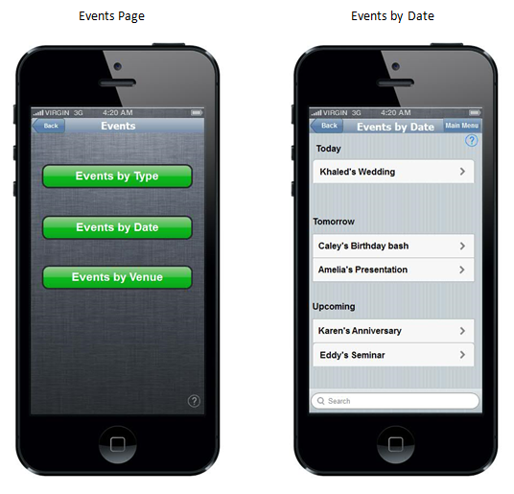 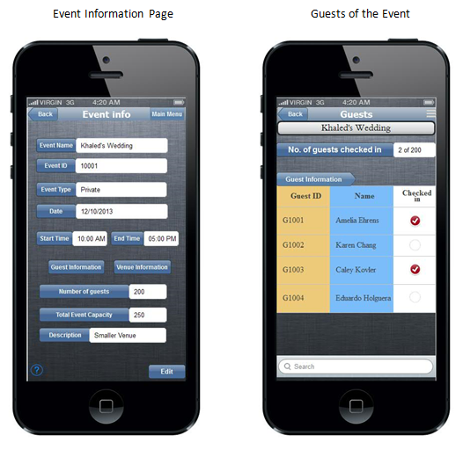

## Justify-app: (in progress)

Justify is a tool that facilitates decision making through rational segregation of arguments. This app is being developed in MIT lab and our team from Bentley university (Intelligent user interfaces) has been developing intelligent realtor website which uses justify app as a backend argument system supporting the website. This project is currently in progress developing mockups for the interface.

No. of Team members: 5

My major contributions: Paper prototypes

Tools used: Blasamiq

Process Flow:

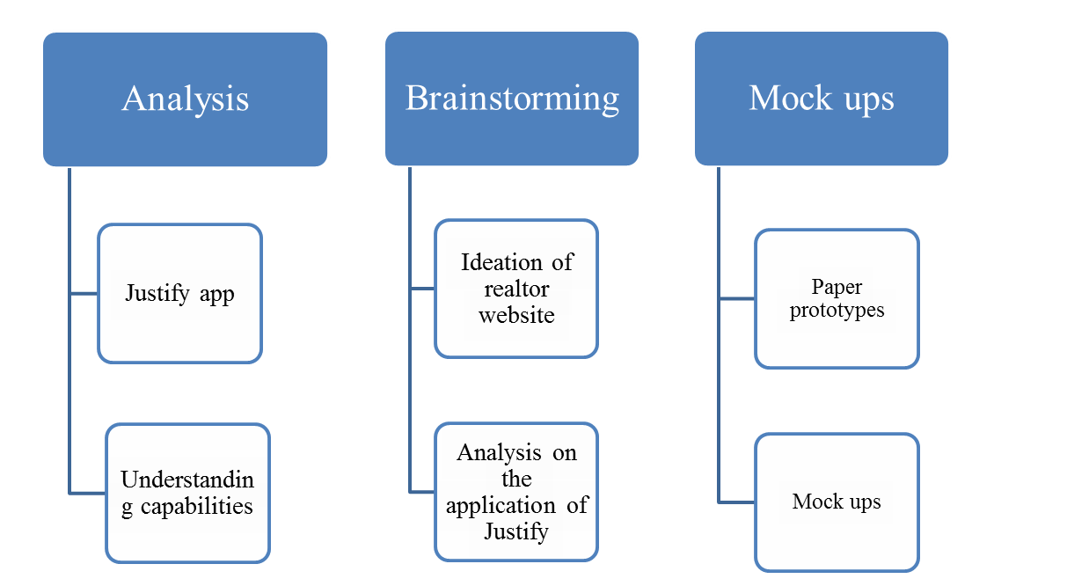

Paper prototype:

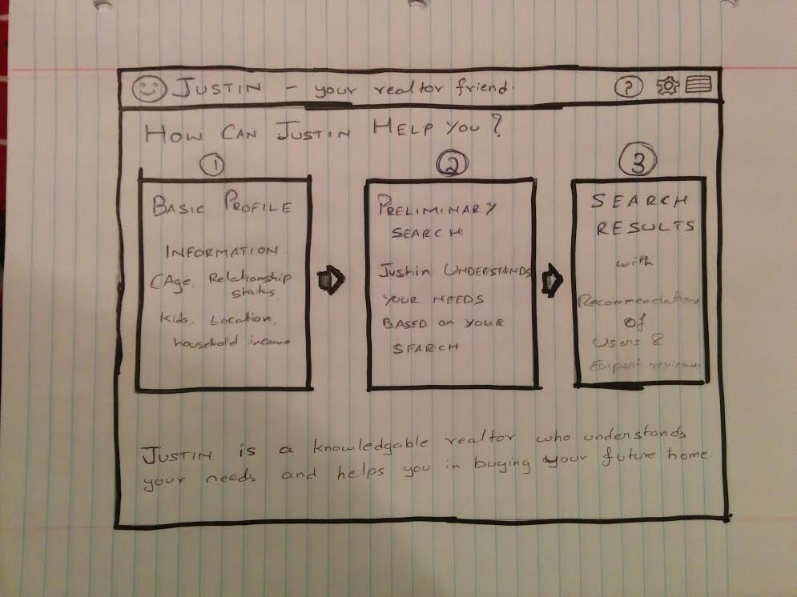

# USABILITY TESTING

## Access management system: (in progress)

Usability testing on access management system prototype is being conducted as part of the course work. This project is currently in the participant recruitment stage. Most the information about the project could not be mentioned due to NDA restrictions.

No. of Team members: 4

My major contributions so far: Logo design, User tasks, participant recruitment

Tools used: pixlr editor, qualtrics software, Lino, Cisco webEx, Morae

Process flow:

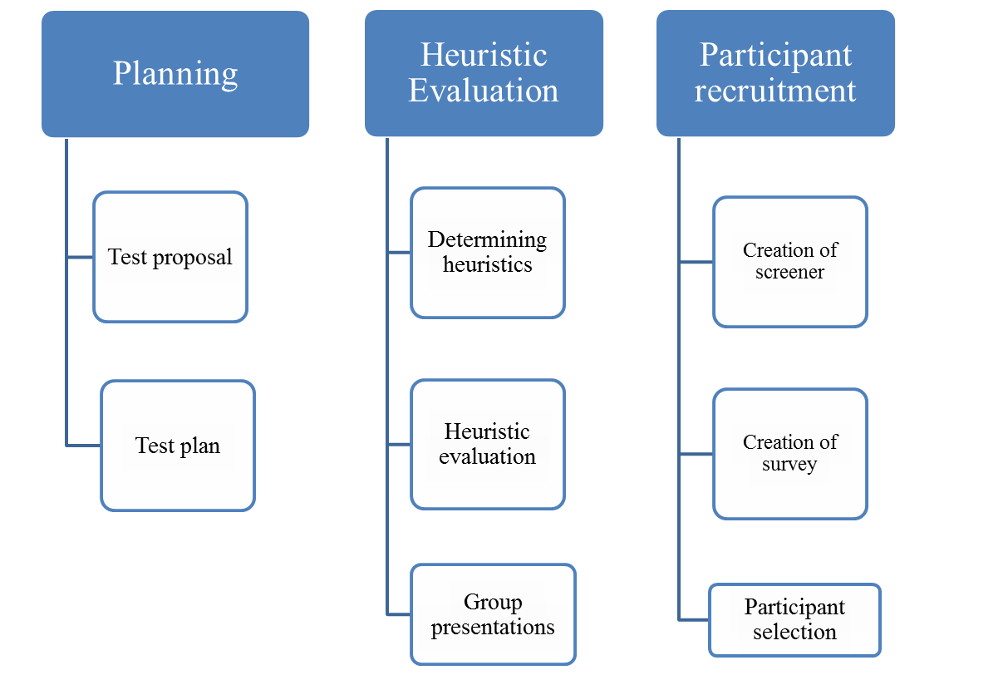

# HEURISTIC EVALUATION

## New England Journal of Medicine (NEJM) website:

This evaluation has been performed during my internship at Massachusetts Medical Society as quality assurance intern. Evaluation has been performed by understanding the customer surveys performed by ‘iperceptions’ survey. Nielsen’s heuristics have been used to perform the evaluation.

Website: www.nejm.org

Process flow:

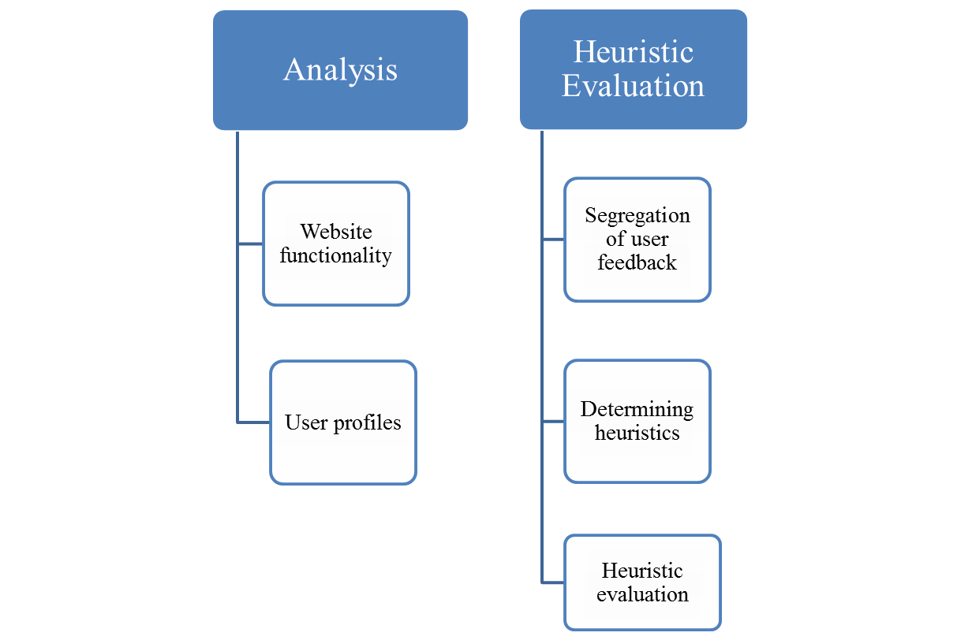

# UX Research

## Currentchoice.com: (in progress)

This project is an academic project related to user research methods. The website provides an online service to switch utility/electricity providers in deregulated states. I have explored different research methods that can be implemented to understand and achieve the goals of the clients. I am planning to perform semi structured interviews and the project currently is in the stage of participant recruitment.

Website: www.currentchoice.com

Tools used: Qualtrics software

Process Flow:

